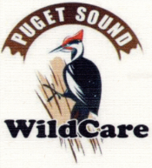  Puget Sound WildCare  2018 Auction Sponsor Sign-up | 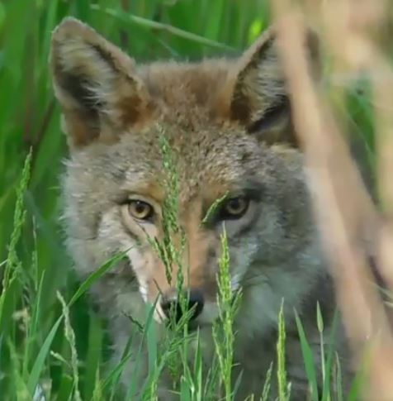
Date: May 6, 2018 Time: 1:00 pm to 4:00 pm. Registration opens at 12:30 pm.
Location: Renton Technical College, 3000 NE 4th Street, Building I, Renton, WA 98056

Puget Sound WildCare is the only licensed general wildlife center in King County dedicated to the care, rehabilitation, and release of orphaned and injured wildlife. This year we will treat an ever-increasing number of animals—upwards of 3,000—that have been orphaned or injured in the wild.

Since we rely on our volunteers and on animal advocates for our success, our Annual Auction is the source of much of our annual budget. We are grateful to those animal lovers who contribute with their sponsorship and their gifts.

 | Levels | Amount | Benefits*
 | Bronze | $100-249 | Name in Program as Bronze sponsor.
 | Silver | $250-$499 | Name in Program as Silver sponsor. 2 Tickets to Auction.
 | Gold | $500-$999 | Page in Program as Gold Sponsor, Special Post in Facebook. 4 Tickets to Auction.
 | Platinum | $1000-$4999 | Page in Program as Platinum Sponsor, Special Post in Facebook. 6 Tickets to Auction.
 | Diamond | $5000 and Over | Page in Program as Diamond Sponsor, Special Post in Facebook, Banner at the Auction, Certificate of Thanks awarded at Auction, Ad on our Webpage. 8 Tickets to Auction.
Company ____________________________________________________________________
Contact ________________________________ Title _________________________________
Phone ______________________ Email ___________________________________________
Address _____________________________________________________________________
City ________________________ State _________ Zip _________ Amount $_______________
Name as to appear in Program _____________________________________________________
*For mention in program, sponsorship form must be submitted and sponsorship paid in full by April 15, 2018.
Tickets include luncheon.

